**Effects of learning self-defense on mind, body and personality**

**(collaborated)**

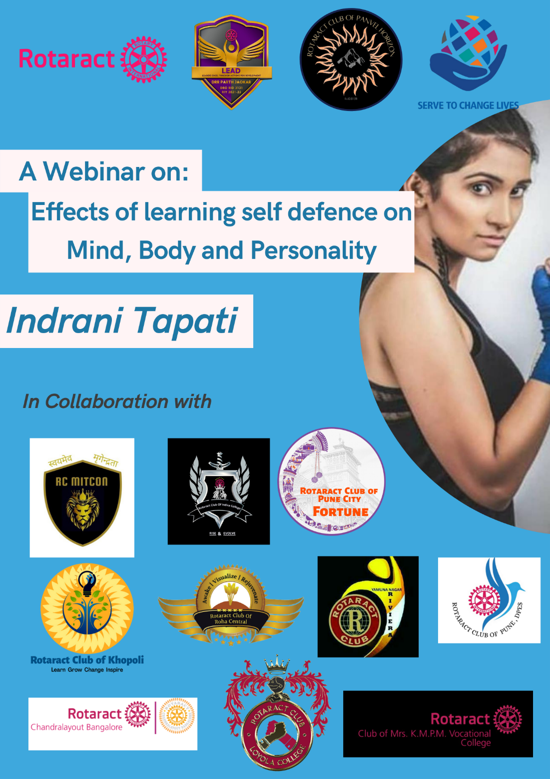

**Event in brief:**

* **Date: 02/02/2022**
* **Time: 6:00 pm onwards**
* **Venue: Google Meet**
* **No of member from our club: 17**
* **Collaborating Clubs:**
  1. **Rotaract club of Panvel Horizon (host Club)**
  2. **Rotaract club of Indira college**
  3. **Rotaract club of Roha Central**
  4. **Rotaract club of yamunanagar riviera**
  5. **Rotaract club of DPES**
  6. **Rotaract club of Khopoli**
  7. **Rotaract club of Mrs KMPM vocational college**
  8. **Rotaract club of Chandralayout Bangalore**
  9. **Rotaract club of Loyola College**
  10. **Rotaract club of mitcoin**
* **Agenda:**

**She speaker began with speaking about the topic of the webinar “effects of learning self defence on mind, body and personality”**

**6:25 - She spoke about her journey and experience to winning a National Gold**

**6:30 - There was some discussion on how teenagers can communicate effectively with their parents to achieve their goals and future plans.**

* **Pictures:**

